Lab 9 Arrays and Objects Drills

Instructions
- Answer the below question in the boxes if needed.
- Code on your computer and zip all your code before submission.
- Please submit the assignment after you finish.

Part 0 Preface
This lab is the most challenging and difficult lab exercise in this chapter. If you find that you're stuck, don’t be mad at yourself as this exercise is really tough. Be patient and try again when your mind is clearer. Also, You can always reach out to the teaching team via office hours, or lab sessions for help.

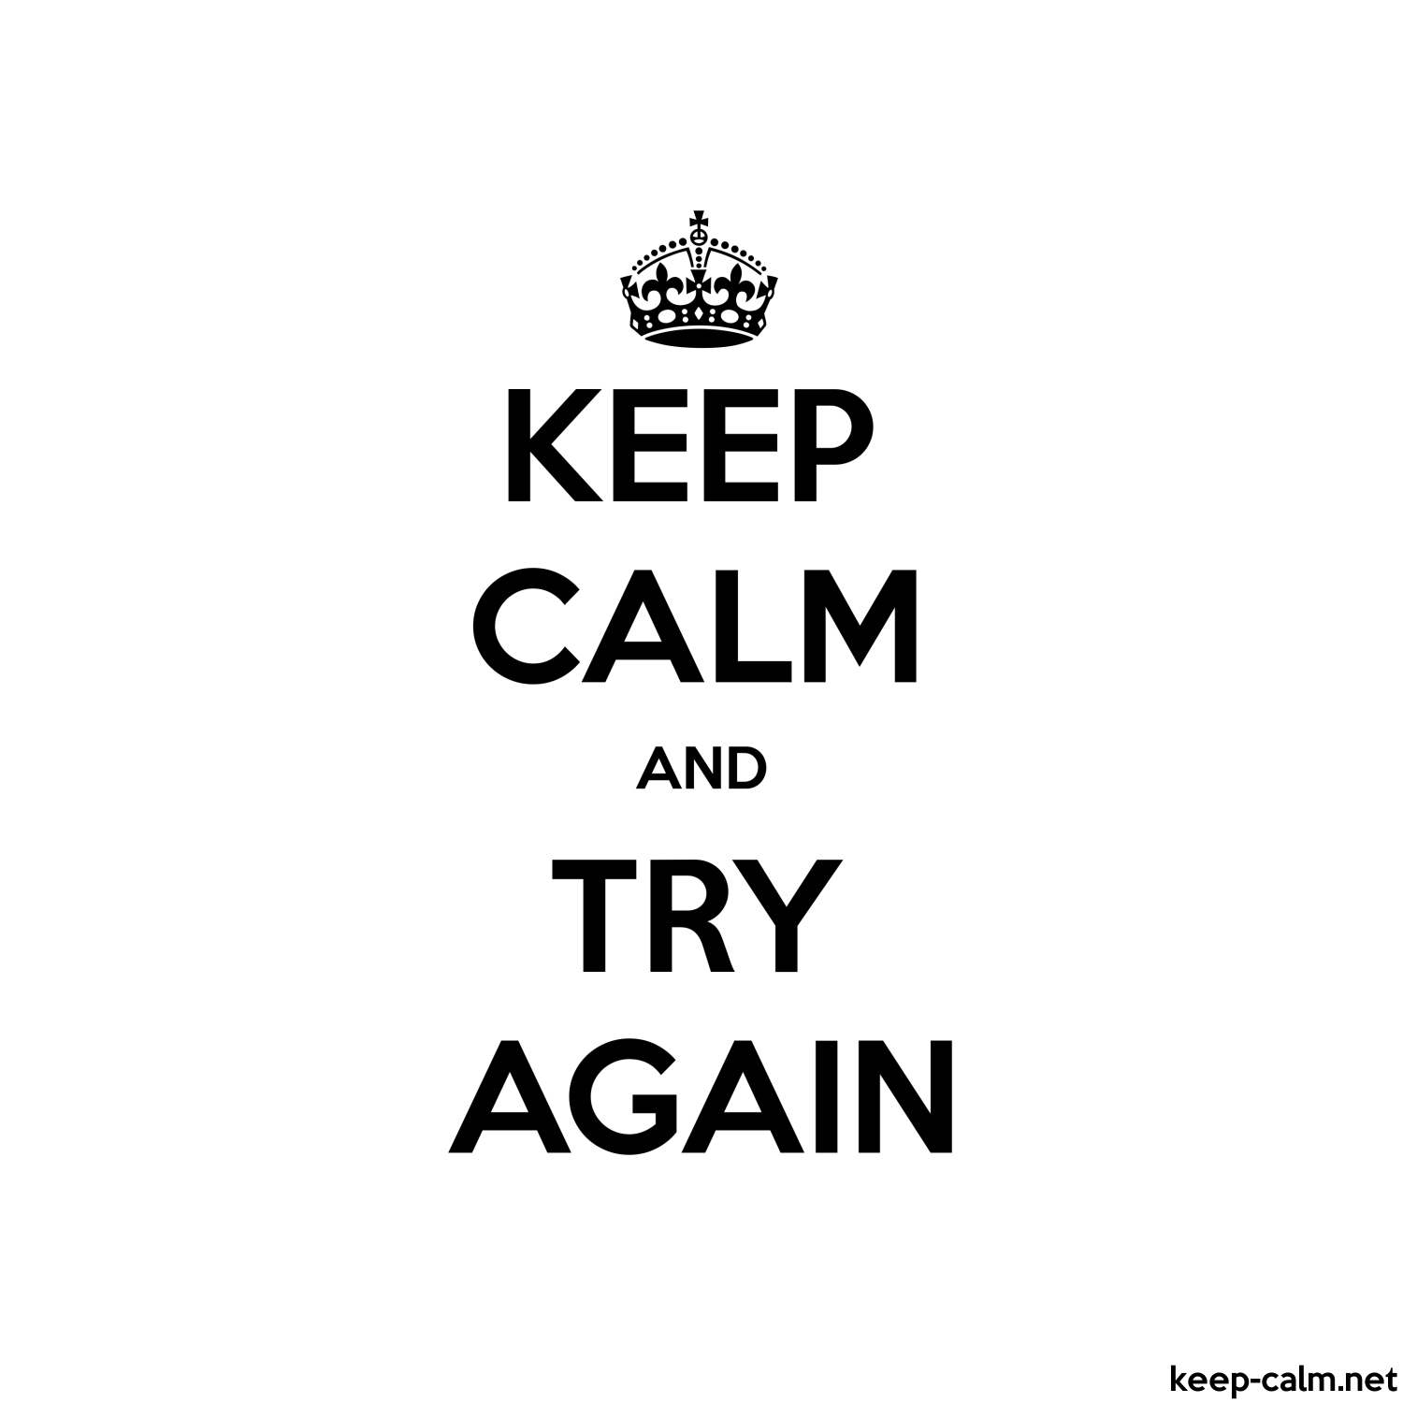

Part 1 Coding Exercise
Download the code package and unzip it. Then open the folder with Visual Studio Code.There are 4 sub-folders with different numbers of exercises for you to work on.

Folder 01 and 02 will test you on your learnings from the reading materials, and ability of reading JavaScript documentations.

Folder 03 and 04 will test your on the array.filter and array.map function which is covered in the “Functional Array Methods” section of the lecture notes.

You are required to complete or create some functions to fulfil the tasks. Please read the instructions carefully and finish all the tasks.

Make sure you test your code before submission. If you are not sure how to run the code, please check the steps in the previous labs.

Each of the exercise file is composed of the following parts:
- Task - exercise specifications
- Your code here - the place where you write your code
- Test case - a piece of code for you to run and test your function
- Expected output - if your code is successful, the console should output with this results

